Week -5 Homework-3

Name: Himavanth reddy putta Id:18759

Q3)

Python code:

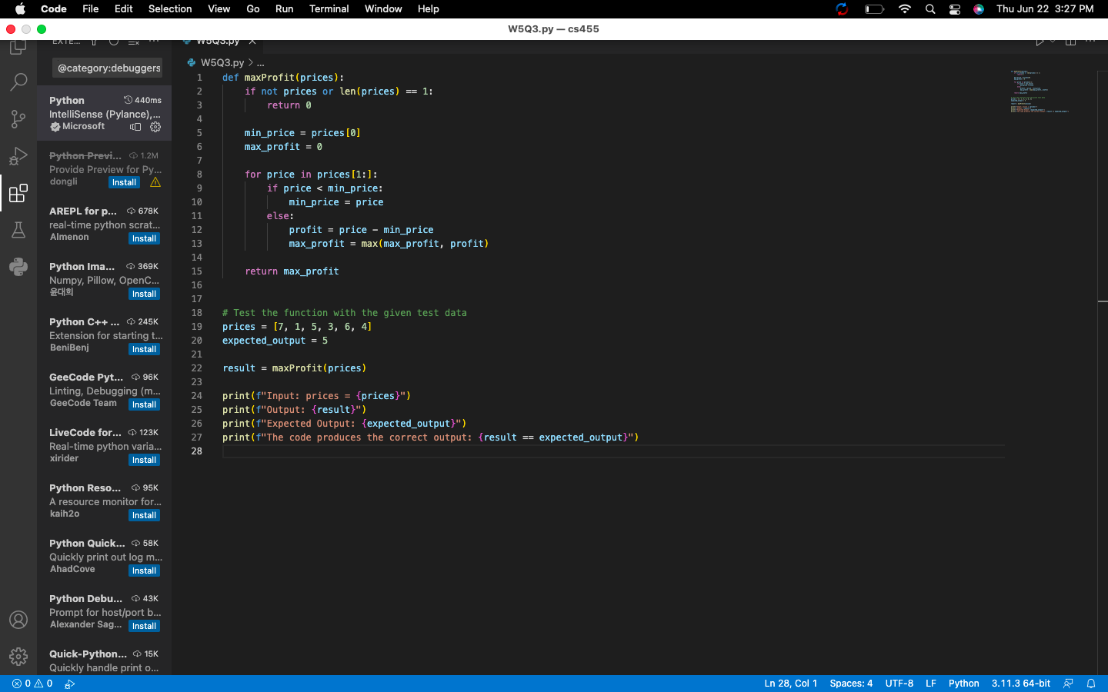

Test Code:

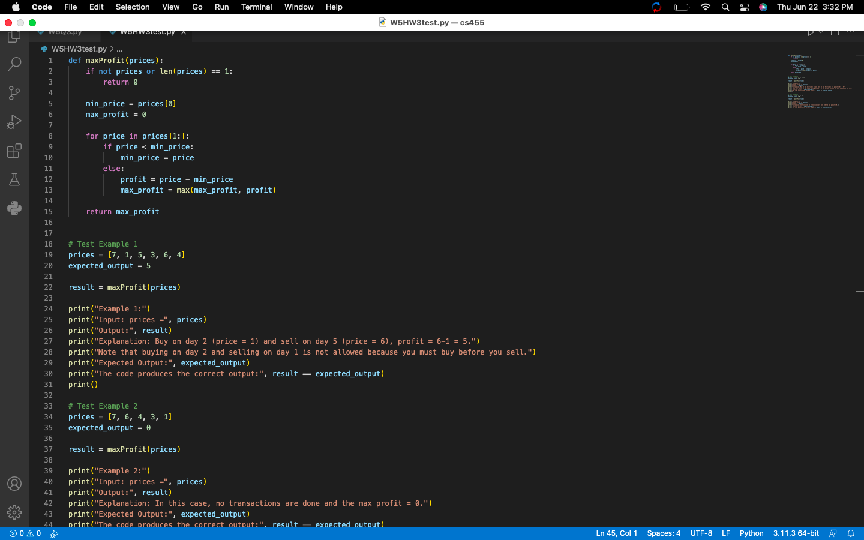

Output:

